what this page is for:
to keep the game’s vibe consistent while we build the prototype.
everyone on the team can read this once and get what beyond cooked feels like.
also because i wanted to flex what i learned from 6 weeks of graphic design

core vibe:
- overcooked chaos with a bit of lethal company tension
- space chefs trying to survive and feed a world-eating monster
- funny first, creepy second
- cosmic horror but no one takes it seriously enough

goal for prototype
- one planet
- two dishes
- one monster that messes with the crew
- test if yelling with friends is fun and not annoying

tone
- comedy through disaster
- “why is the stove floating again” kind of energy
- weird, a bit unsettling, but never straight horror
- small moments of calm before things explode

THE LOOKS (my job i suppose)
- 3D, simple shapes
- bright colors in dark places
- everything looks old, taped together, like it’s been fixed too many times
- gravity breaks sometimes, just because
- My suggestion: human-like body and then you could just slap a customizable texture on said shape like this (very funny though it might not be as cartoony as the your original idea)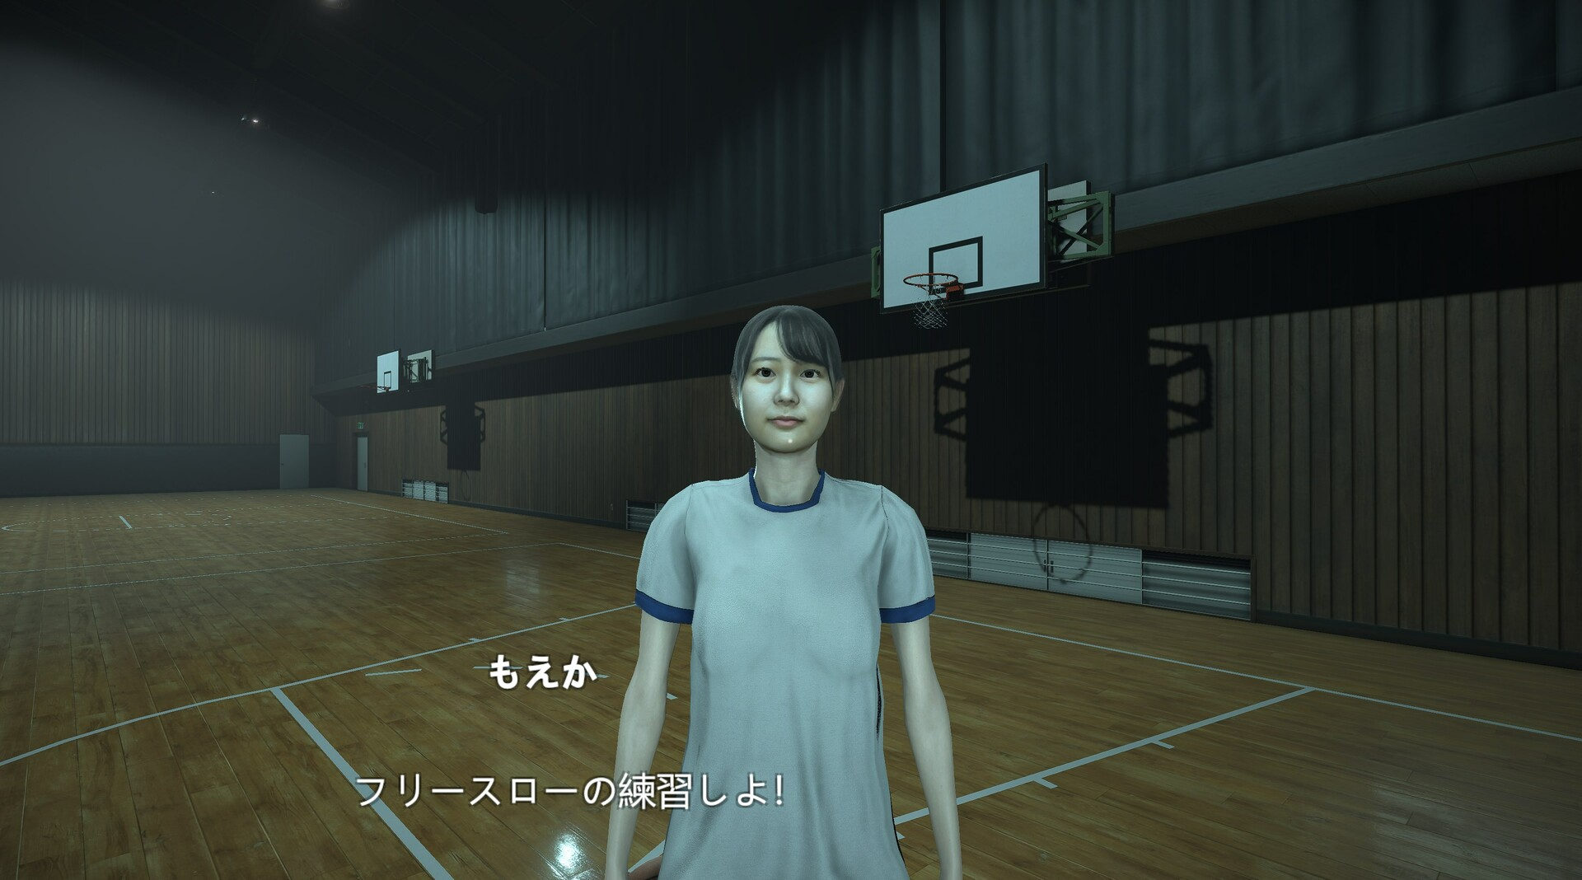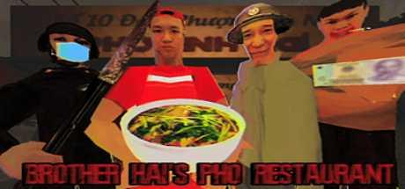

sound
- no constant music, use noise to sell chaos
- funny timing with sound cues (alarm beeps that stop halfway, frying sounds too loud)
- background chatter or weird static from the Devourer
- keep voice lines short and messy

how players should feel
- stressed but laughing
- proud when something actually works
- yelling about missing ingredients
- always one step away from total disaster

writing style
- GCF logs (short mission notes, sarcastic tone)
- characters who argue mid-task
- monster speaks in half-understood rumbles, like it’s bored but still hungry

planet ideas
- frozen one where heat runs out fast
- jungle one where the plants fight back
- gas planet where noise attracts danger

what success looks like
- ten minutes of funny chaos
- people replay because they want to do better next time
- simple mechanics but a lot of personality

